Access Control List (ACL)
An Access Control List (ACL) is a set of rules that define which users or groups have what kind of access (read, write, execute) to a specific file or directory. ACLs provide more fine-grained permission management than the standard owner-group-other permission model.

Verify the Default ACL on a File/Folder
To check the default ACL settings of a file or directory, use the command:
getfacl <file/foldername>

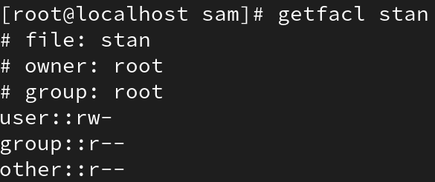

Set ACL on a File for a Specific User
Use setfacl with the -m (modify) option to assign permissions to a specific user:
setfacl -m u:username:rwx filename
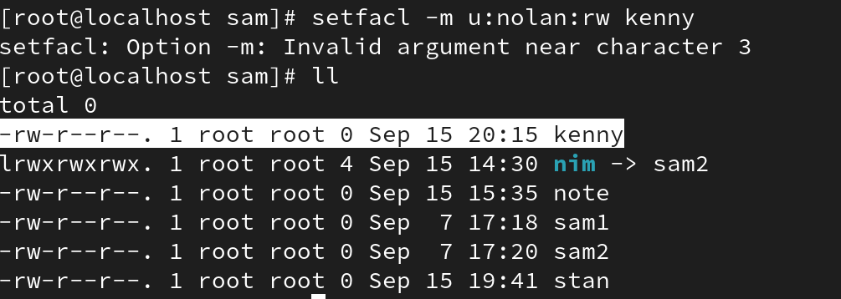
setfacl -m u:username:7 filename
The 'rwx' or '7' represents read, write, and execute permissions.

Set ACL on a File for a Specific Group
Similarly, you can assign ACL permissions to a group:
setfacl -m g:groupname:rwx filename

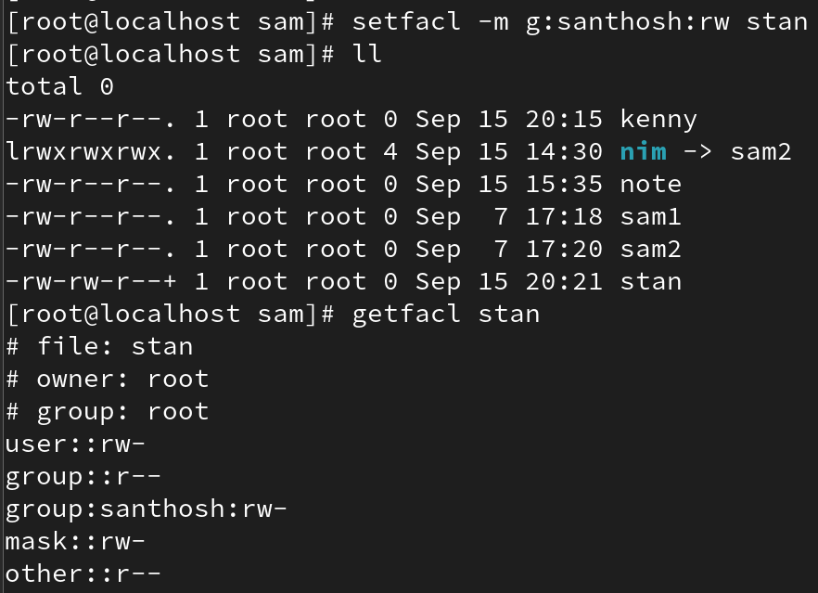
setfacl -m g:groupname:7 filename

Remove ACL for a Specific User
To remove ACL permissions for a particular user:
setfacl -x u:username /path/to/file_or_directory
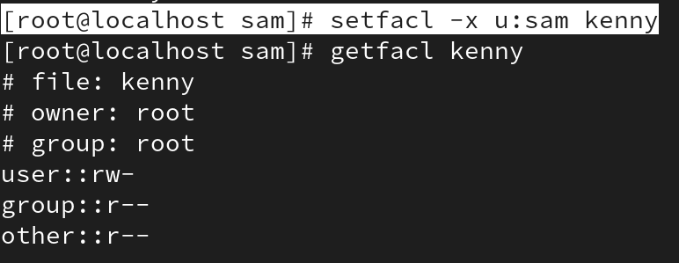

Remove ACL for a Specific Group
To remove ACL permissions for a specific group:
setfacl -x g:groupname /path/to/file_or_directory
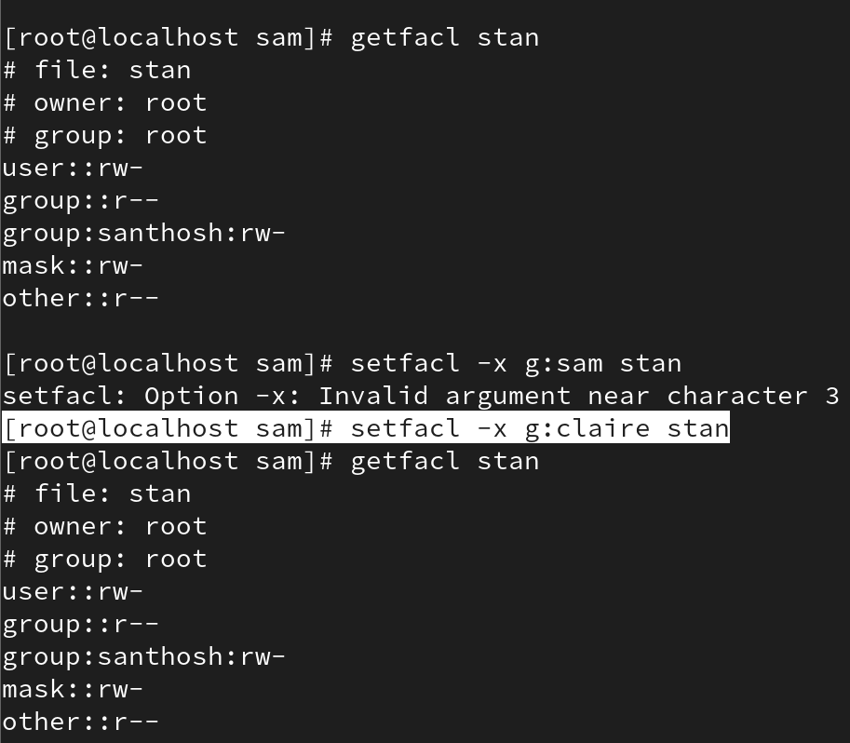

Remove All ACLs
To remove all ACL entries from a file or directory:
# setfacl -b file_or_directory
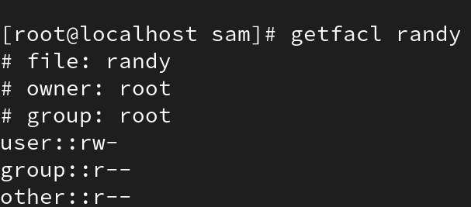
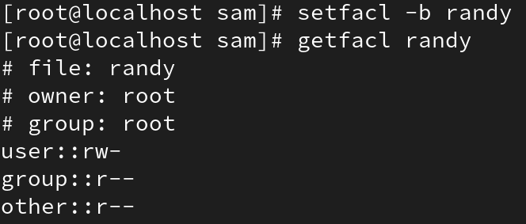

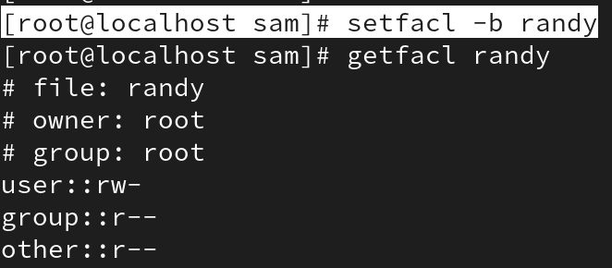
This command clears all ACLs, reverting to the standard Linux permission system.

Additional Examples
Recursive Operations:
getfacl -R /secure # Recursively list ACLs
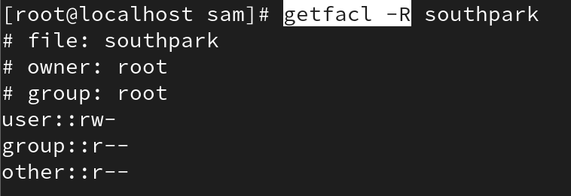
To remove Recursively ACLs
# setfacl -R -b u:username: filename # Recursively ACLs
